Problem statement1: Find the top five kinds of GoogleKnowlege_Occupation people who were guests in the show, in a particular time period. Take the time period as 1/11/99 to 6/11/99 i.e., 6 months .

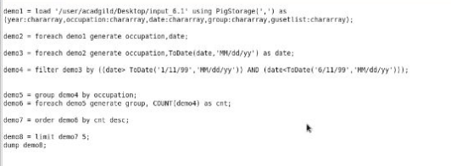

Problem statement2: Find the number of Google Knowledge occupation types in each group, who have been guests on the show. 